# CS 255 System Design Document

## UML Diagrams

### UML Use Case Diagram

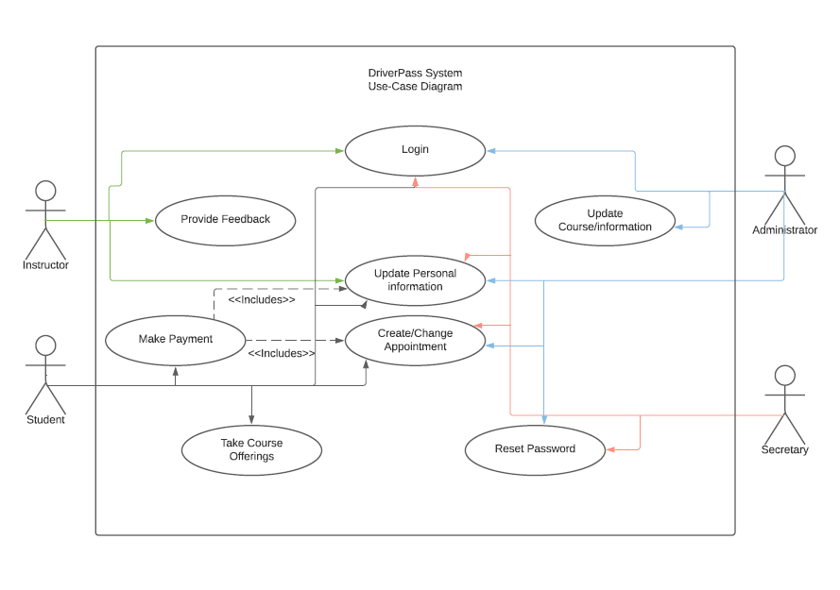

### UML Activity Diagrams

### UML Sequence Diagram

### UML Class Diagram

## Technical Requirements

This system will require a cloud based, scalable design. To that extent the hardware specifications for the owners (DriverPass) will be very limited, they will require internet access and standard PCs with one of the several most popular browsers. In terms of clients the client will need access to a PC as well but with a mobile first design (for the student and instructor side) this limitation could be overcome with limited additional work.

In terms of software all users will require access to a web browser to access the site with an average internet connection. The administrators and secretary should additionally have a word editor and excel style spreadsheet program for reports. It is extremely important that response times average below 1 second as users navigate the site. In this way the sit should be built in a way that brings up the page first, then loads subsequent components and sub-components to ensure user experience is responsive and reactive.

The administrator of the site will be must me able to pull activity and student reports and will have all permissions on the site. The secretary will be able to reset passwords, view and modify schedules and view information on any non-administrative user. The instructors primary use for the website will be to view their personal driving schedule, provide student driver feedback and update personal information. The student will use the site to view course material, view schedule, add/update/change appointment, update personal information (such as address or billing info), make payments and view instructor feedback.

The major limitations and technical must have for this system are that all users need access to the internet, preferably through a PC, and the cloud needs constant or near constant uptime. If these requirements are met the system should work as intended. No additional infrastructure besides the existing cloud and internet infrastructure will need to be developed for the purposes of this system, and the database will be on the cloud as well to consolidate resources.